Family law News

What’s Inside:
- Office News
- Parent & Kid News
- Collaborative Law
- Services Offered

OFFICE NEWS:
- I now have office space in Westminster and Owings Mills for meeting clients.
- By popular demand, I now have the ability to accept credit and debit card payments. Let’s get those balances paid up.
- Did you know I provide full family related services for: prenuptial, divorce, custody, visitation, support, contempt, enforcement, settlement options, step adoptions, etc?
- Did you know that I can help with special education meetings for your special needs child?
- Did you know that I also prepare simple wills, power of attorney, and advanced health directives? GET A SUMMER DISCOUNT!
PARENT & KID NEWS:
When going through a divorce, parents often worry about the emotional effects on their children. A recent article by Carole Mackenzie addressed this issue in an effort to help parents. She stressed that the effects listed vary depending on the individual child, their age, etc. Overall, children may experience a wide range of emotions, and they may be extra distressing. The following is taken from her article on www.dealwithdivorce.com.
Insecure and afraid of the future: The many and often unavoidable changes that accompany divorce can undermine a child’s sense of security and make them fearful of the future – about “what’s next?” Will we be poor, will we have enough to eat, will I have to go to a new school, will I lose my pet rabbit, will I still see my friends?
Fearful of being abandoned: From a child’s perspective, the unimaginable has happened – a parent is no longer at home. Children may be deeply afraid that the other parent is going to “disappear” too and leave them alone.
Rejected: Children of divorce may feel rejected and unloved by the parent who has left. This makes little sense until we remember that children perceive themselves as the center of the universe.
At fault: Children may believe the divorce is their fault, caused by something they said or did, or just the way they are, and feel a deep sense of guilt and shame. Even difficult teens may be afraid that their behavior has contributed to the divorce and made it easier for a parent to leave.
Powerless: Children who feel responsible for problems between parents tend to believe they can also fix things. They may go to great lengths to be a “better child” – a more helpful and appealing child – or believe they have the power to “wish” their parents back together again. When this doesn’t happen – when their often elaborate plans and hopes for reconciliation fail – children feel powerless and upset that they cannot make a difference.
Torn in two: The most damaging effect of divorce on children is the emotional trauma caused by parents who fight or belittle each other in front of their children. Children feel expected to take sides but cannot do this without being disloyal to the other parent. However, by not taking sides they fear disapproval and rejection by both. They are trapped in a no-win situation where it is “wrong” to love both.
Sad: Children of divorce may feel a huge sense of loss and sadness, believing that the absent parent has gone forever and that they no longer have a family – a way of life is at an end.
Stressed: During divorce, children may feel stressed and under pressure to do more than they can realistically cope with at a time that is already stressful enough. They may be used as a confidante and advisor by one or both parents, a role that even teens are not qualified for or comfortable with. Lonely: Children may miss the intimacy, comfort and particular parenting skills of the absent parent. The parent at home may be so wrapped up in their own problems that they are not available to their children. Circumstances may have cut them off from their usual playmates. Children may seek intimacy and comfort elsewhere, or become withdrawn.
Angry: Anger is a common emotional effect of divorce caused by lack of understanding or acceptance of the divorce, specific events and changes, emotions that children are not equipped to manage or express, and so on. Children do not always show their anger. It is more common when divorce brings a low-conflict marriage to an end because the reasons for the divorce are not so obvious. Children resent their parents for doing something that in their view is unnecessary.
Depressed: Depression is not a direct emotional effect of divorce but a “second stage” emotion. Depression is a sign that children have not received the support they need to cope with these emotions.

How you can help: The emotional effects of divorce are within your control.

- Notice how most of these emotions stem
from the way a child thinks about divorce – about themselves, their parents and the effect of divorce on their life. This is why the way you talk to children about divorce is important. By monitoring and managing the way your children think about divorce, you can nip these emotions in the bud.

- You can watch your own behavior, ensuring
that you do not overestimate your child’s maturity, that you are available to your children and that you keep negative feelings about your spouse under wraps.

YOU CAN DO IT!
July 2008 | Volume 1, Issue 2

the law office of dawn a. nee, llc

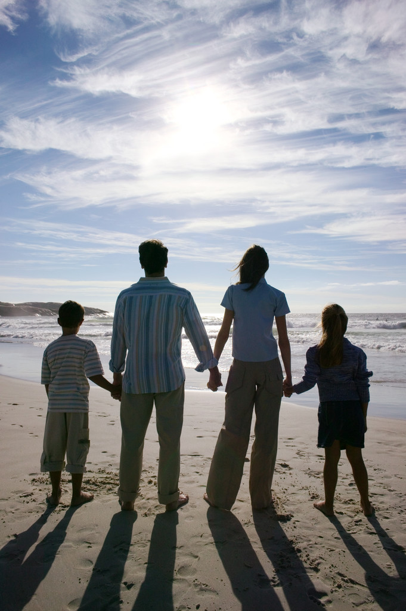
LOOKING TO THE FUTURE

Law Office of Dawn A. Nee, LLC
PO Box 791, Manchester, MD 21102
Phone – (443) 552-9660
Fax – (443) 443-522-9662
dawn@dawneelaw.com
Offering you options: Collaborative Law, Mediation and Litigation

Family law News Page 2

They can help your children express their thoughts and feelings about your divorce. They can help your kids cope with having two homes and divorced parents. They can help you and your kids keep track of custody schedules. They can make your job of co-parenting easier, and keep your child out of the middle.
They aren't a miracle cure for divorce, but My Two Homes products, from LadyBug Press, can help make your life a little easier. Specially designed for divorcing parents and their kids, LadyBug's product line includes: n The Divorce Calendar for Kids. Giving kids a visual fun way to keep track of their schedules, the package includes a 15-page calendar, two pens, and 444 colorful stickers. The "Mom" and "Dad" stickers show which parent the child will be with on a particular day or week, and other stickers include activities, holidays, and birthdays. Developed by a team of divorce mediators and an attorney, My Two Homes Products products are designed to help children communicate their feelings of fear, anger, and abandonment engendered by their parents' divorce.
- The Mom and Dad Pad. This provides easy-to-use form letters for routine communication (school events, appointments, etc.) that may make dealing with your ex a little easier. The fill-in-the-blanks letters for frequently recurring topics make sending and receiving requests and information less stressful. The tone is very positive, and the form even has an area for one parent to let the other know about milestones or special progress in the child's life. Use the Mom and Dad Pad instead of your kids to send your messages -- everyone will be happier.
- Photo Album for Kids. This pocket album lets kids keep their loved ones with them no matter where they are. The album helps your child feel connected to you when he or she is at the other home.
- The Magic Handbook. Filled with magic thoughts and words to protect your child, the Handbook helps kids communicate with their parents and cope with living in two homes.
Developed by a team of divorce mediators and an attorney, My Two Homes Products products are designed to help children communicate their feelings of fear, anger, and abandonment engendered by their parents' divorce.
FamilyStories: My Two Homes, by Susan Magsamen, Sterling Publishing, 2007; $17.95; www.sterlingpub.com. For kids whose parents are splitting up, some unusual self-help: a book of advice plus a cool three-ring binder for calendars and schedules, contact info and ways to organize and stay calm.

We’re on the Web!
See us at: www.dawnneelaw.com

This newsletter is for advertising and does not create an attorney –client relationship


